## **Use case diagram**

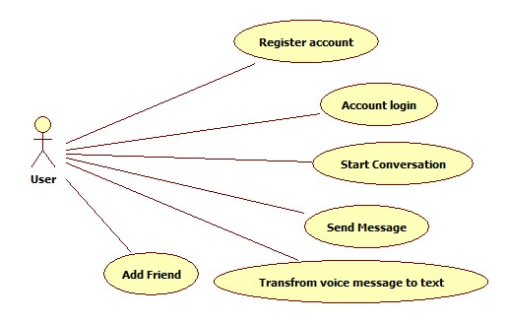

Figure 1.1 Use case diagram

## **Use Cases**

|  |  |
| --- | --- |
| Use Case Name | Send Message |
| Actor | App user |
| Description | Users want to send a message to friends. They can send two type of message either voice or text. |

|  |  |
| --- | --- |
| Use Case Name | Transform voice message to text |
| Actor | App user |
| Description | Users want to transform a voice message which is not clear enough to a text message. |

|  |  |
| --- | --- |
| Use Case Name | Add friend |
| Actor | App user |
| Description | Users want to add a new friend. After added successful, system will display in friend list. |